Name
Number/Street Name
Suburb
State/Postcode

Date

Would you like to in a research project at The Royal Children’s Hospital?

Dear <person’s name>

We are contacting you because you might be interested in taking part in a new research project at The Royal Children’s Hospital. Our records show that you might live at this address.

If you are interested in finding out more about the research project, please contact us. You can call <researcher name> on <phone number>. Alternatively, you can email <researcher name> at <email address>. Please let us know if we can send you some information about the research project.

Please also let us know if you do not want us to send you information or contact you again. If this is the case, we will remove your details from our records.

If <insert name> is no longer at this address, but you know how to reach them, we would be grateful if you would give this letter to them.

Thank you for your time.

Kind regards

Name
Department
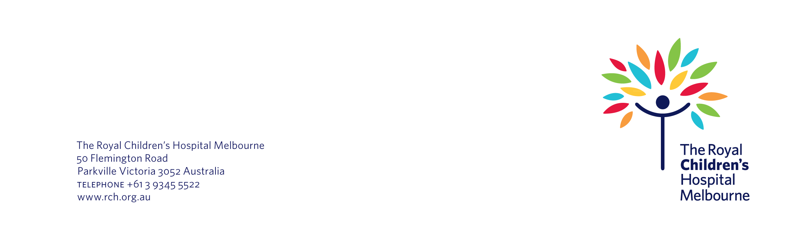
The Royal Children’s Hospital

